



ADMINISTRATIVE SUPPORT TEAM
(255)
NATIONAL 2021

Production:
Job 1: Spreadsheet __________ (100 points)
Job 2: Letter Mail Merge __________ (100 points)
Job 3: Presentation __________ (100 points)
Job 4: Report __________ (100 points)
TOTAL POINTS __________ (400 points)

Test Time: 90 minutes

GENERAL INSTRUCTIONS

- Check that this test booklet contains Jobs 1-4.

- Correct all errors. Copy is graded on production standards.

- In places you normally use your reference initials, use your team’s number. Your name or initials should not appear on any work your team submits. Key your team’s number and job number in the footer in the lower right corner of all work submitted unless specified otherwise.

- If you finish before the end of the testing time, notify the proctor. Time may be a factor in determining a winner when there is a tie score.

- When turning in your contest, the jobs should be arranged in numeric order. Use your time wisely. You have ninety (90) minutes to complete this test.

- Save all work with your team number on the flash drive provided by the contest administrator.

Production Standards (when specified):
0 errors 100% of assigned point value of each document
1 error 90% of assigned point value of each document
2 errors 70% of assigned point value of each document
3 errors 50% of assigned point value of each document
4 or more errors 0% of assigned point value of each document

TEAM INSTRUCTIONS
You are part of the Administrative Support Team for Digital Solutions, 700 Morris Road, Suite 201, Columbus, OH 43214. Be sure to use the Style & Reference Manual as a guide in preparing the documents.


Job 1: Spreadsheet

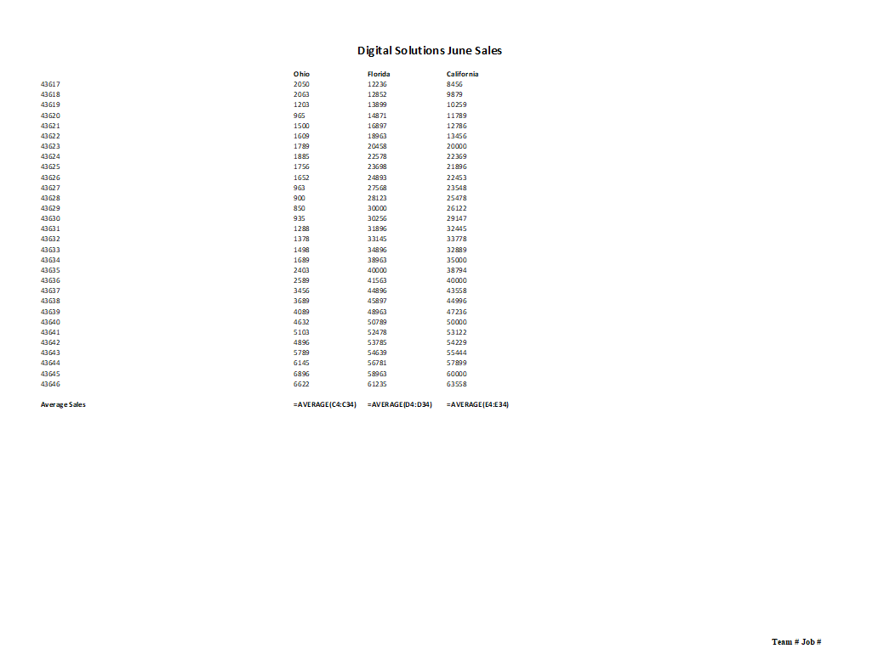

Job 2: Letter Mail Merge- Field Names
Letter
First Page Top Margin: 2" Second and Subsequent Page Top Margin: 1”
Side Margins: 1"
Use open punctuation

Current Date

Dear «Name»
Digital Solutions appreciates you participating as a vendor during our Tech Expo in Orlando. There will be over 50,000 participants coming in to learn more about the newest technologies that will be available in the upcoming future.
Below is your vendor location, time for set up and booth size that you requested.
• «Location»
• «Time»
• «Booth_Size»
We will have a vendor lounge located at the east ballroom for you to partake in. We will have massage chairs, food and private areas for you to work and make calls as needed.
If you have any questions please contact Edna Renick at 614-895-7277.
Sincerely

Nancy Wells
CEO

Team ID#

Team ID# Job #

Job 2: Letter Mail Merge- Letter

Current Date

Dear You Go App Technologies
Digital Solutions appreciates you participating as a vendor during our Tech Expo in Orlando. There will be over 50,000 participants coming in to learn more about the newest technologies will be available in the upcoming future.
Below is your vendor location, time for set up and booth size that you requested.
• Grand Ballroom
• 9:00 a.m.
• Large
We will have a vendor lounge located at the east ballroom for you to partake in. We will have massage chairs, food and private areas for you to work and make calls as needed.
If you have any questions please contact Edna Renick at 614-895-7277.
Sincerely

Nancy Wells
CEO

Team ID#
Team ID# Job #

Job 3: Presentation
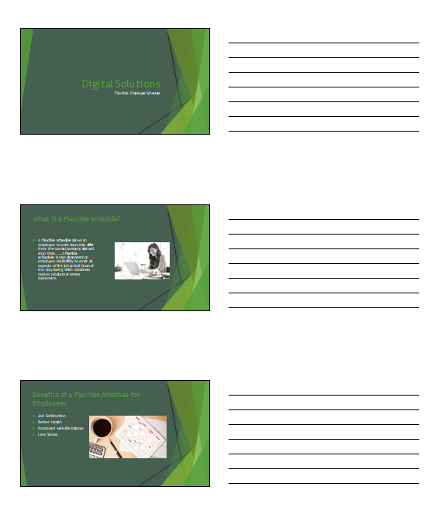

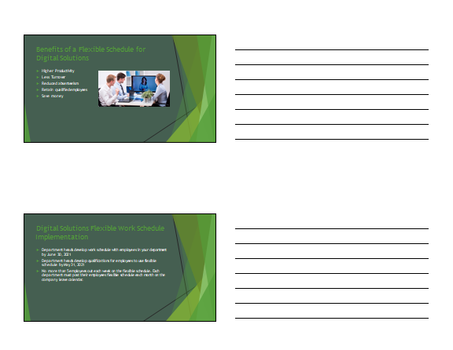
Job 4: Report
Team ID 1
Report
(MLA Style) Top Margin: 1" Side Margins: 1"
Spacing of Body: DS

Nancy Wells
Harvey Rosen, Tom Carlson, Julie Smith, Roger Meyer, Edna Renick
Financial Services Department, Information Technology Department, Human Resources Department, Marketing Department, Administrative Support Department
Current Date (in military style)
Flexible Working Schedule
The world of work is fast changing. As life expectancy lengthens and labor markets shift, our working lives have become more complicated. The old expectations about how we work have become unsustainable—not least, the expectation that we religiously travel to and from a fixed location ten times a week during rush hour, with all the knock-on effects that this has for carbon emissions.
Flexible work has the potential to solve many issues that see people fall out of the workforce. For employees, this means being better able to fit their jobs around other responsibilities, such as looking after children or elderly relatives. For businesses, this means retaining staff and saving the tens of thousands of dollars it costs to replace them.
Yet many remain stuck in positions with rigid working hours. One of the sticking points for employers seems to be that flexible work is equated with the one or two formats that they are familiar with—most often, letting staff work from home or work part-time. So a whole battery of ways in which flexible work could be used to align with the needs of a diverse workforce gets overlooked.
Recent research mapping the various combinations of flexible work found over 300 possible ways in which jobs could be organized flexibly. This includes job shares, compressed hours, term-time working, flexi-hours, and tapered working. There is considerable scope to draw upon this host of working practices.
Team ID 2
Here are four ways that businesses can get flexible working to work for them and their staff.
Get Department Chairs on Board
First and foremost, department chairs need training in how to manage flexible work. My own research found that department chairs are the single biggest block on flexible work uptake. Even where flexible work is supported, too often it is assumed that department chairs know the unknowable and can just run with new working practices.
Without any investment being made in managers, flexible working arrangements are set up to fail. Alternatively, the buck gets passed onto the flexible worker to make a success of a new arrangement, giving him or her one more task for their workload and one with a high penalty attached to failure—a stressful experience in itself.
Realistically, achieving this buy-in will also need some nudging, particularly for smaller businesses and sectors where there has been less flexible work. Giving managers access to success stories and practical guidance, backed up by lots of leadership and peer support, is vital.
Be Flexible About Flexibility
Managers and employees need to come together in a safe space to assemble flexible working arrangements that work for everyone, with a real understanding of what is at stake and what is possible. A part of this is the need to get flexible about flexibility—recognizing that circumstances change and that work arrangements may need to be tweaked or even reversed over time to ensure that they remain fit for purpose.

Flexible work has been used as a management tool to achieve savings by imposing remote or zero-hours contracts on workforces, with little input from those called on to do their jobs differently. So it’s necessary to give people space to make suggestions and give feedback about flexible work. It is also about making use of a range of flexible working arrangements.
Team ID 3
Redefine Productivity
Flexible work demands a shift away from seeing productivity in terms of being present for fixed working hours. Indeed, the problem of presentism—where people feel compelled to show their face at work even if they are ill—only feeds into the productivity puzzle.
Companies need to devise better measures of output: has a project been completed within schedule, did the team work well together, is the report of a high quality? These are much more effective yardsticks of success than whether staff clock in at 9 a.m. each morning.
Advertise Your Flexibility
Making flexible work available at the point of hire will widen the talent pools available to employers, as people who already work flexibly will be more likely to apply for positions where they will not lose a valued part of their contract. The demand for such a move is significant—flexible working consultancy Timewise’s latest Flexible Job Index found that 87% of employees either work flexibly or want to. In 2019, only 15% of jobs were advertised as flexible. Employers who ignore this demand will be poorly prepared in the war for talent.
The evidence base for the benefits of well-managed flexible working arrangements is getting more and more compelling. It offers increased retention and productivity and drops in absenteeism. It’s not only employers who stand to make business gains from getting good at managing flexible work—employees with a good work-life balance are more motivated and content. Plus, as the latest gender pay gap figures show that older workers are seeing the greatest disparities, flexible work is a key tool in creating more age-friendly and equitable workplaces.
On a societal level, by organizing work more thoughtfully we can make inroads into tackling carbon emissions as our car use becomes more efficient. We could see reduced demands on health and social care systems as workforce stress levels fall and balancing care and work demands become more manageable. We will only achieve this through good management, a fresh approach to job design, and enthusiasm from all involved.
Team ID 4

Source: https://www.fastcompany.com/90428623/how-employers-can-make-flexible-hours-work-for-everyone

